CIS367 - GFX

Winter 2023

**Lab 4: Blender Basics**

**Synopsis:**

Modeling time! We're going to make a few things in Blender and end up with a house. For this lab, we're going to follow a pair of slides that walk you through setting these things up in an older version of Blender. The instructions translate fairly well and have a reasonable number of screenshots that are helpful.

1. **Setup**

Make sure you have Blender installed on your machines. Also, take some time to peruse the Texture Ninja: <https://texture.ninja/>. Download the following texture files to your machine and put them somewhere reasonable (you'll use them for texturing).

* Wall texture (pick one: <https://texture.ninja/category/Wood/2>)
* Floor texture (pick one: <https://texture.ninja/textures/Brick/1>)

(note you can pick whichever textures you want, I'm just pointing you towards a wood house with a stone/brick foundation)

1. **Part 1**
   1. **Donut Shrine and Bench**

Read through this set of slides: <https://cs.slu.edu/~jfritts/csci1030/schedule/Getting%20Started%20with%20Blender.pdf>

*Updates*

* *To make it wider you'll want to scale it. I find it easiest to hit 'N' to bring out the Transform window and specify exactly the sizing, but up to you.*
* *For subdivide, it is Edge -> Subdivide (or Right Click the top face in Edit mode and Subdivide)*

Create a scene with the donut shrine and the bench. **Take a screenshot and paste it into Q1.**

* 1. **Simple Building**

Continue on with the prior set of slides and make the building. When you get to the collapse area, the location is in Mesh → Delete → Collapse Edges and Faces. **Again, screenshot and paste into Q1.**

***Notes:***

* Snapping should be set to increment to get that nice snappy feeling (to the grid – they say to use Vertices)
* Duplicate is just Shift+D

*Should look kind of like this, albeit with your own interpretation of a house:*

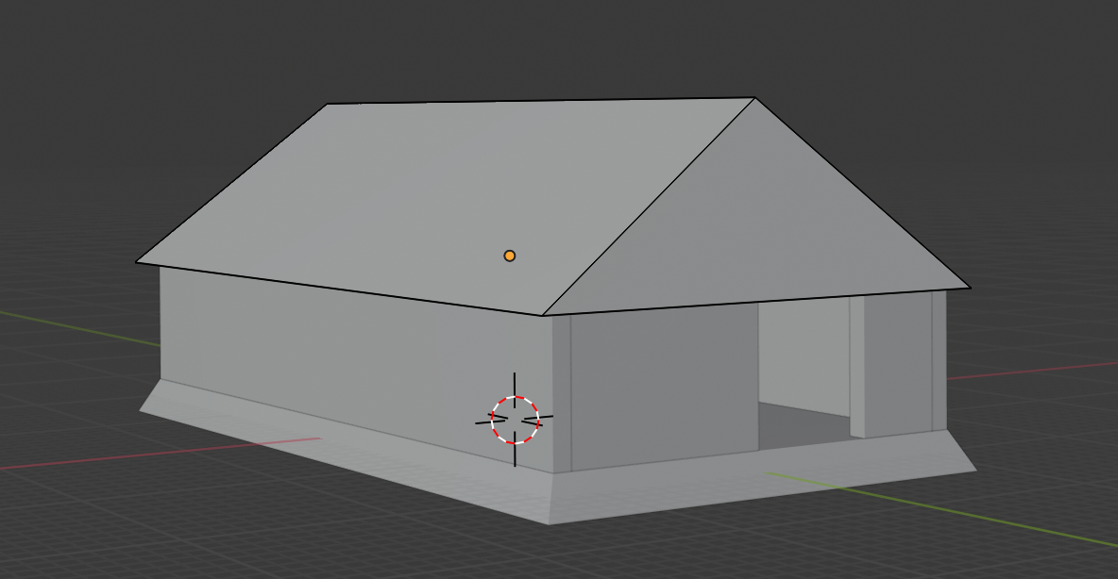

At this point, it is up to you if you want to texture now or later. If you choose to texture now, move on to the second presentation (<https://cs.slu.edu/~jfritts/csci1030/schedule/Getting%20Started%20with%20Blender%20-%20Part%202%20Texturing.pdf>) otherwise continue on and add windows.

*Note: you might need to translate some of the calls in that link to the current version. I have some tips in the following – for screenshots I'm mainly looking for basic texturing.*

When you need to turn on Shading, this is your option (LookDev → Textured Solid was removed in a prior version):

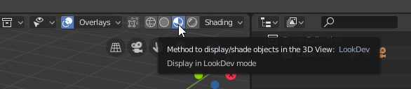

Also, texturing/shading is different now too. First, click on your foundation and then the materials button. You'll be changing it in the Layout view.

First things first, duplicated objects share textures/materials, so we want to remove this dependency. If you try changing the base color you'll see something like this:

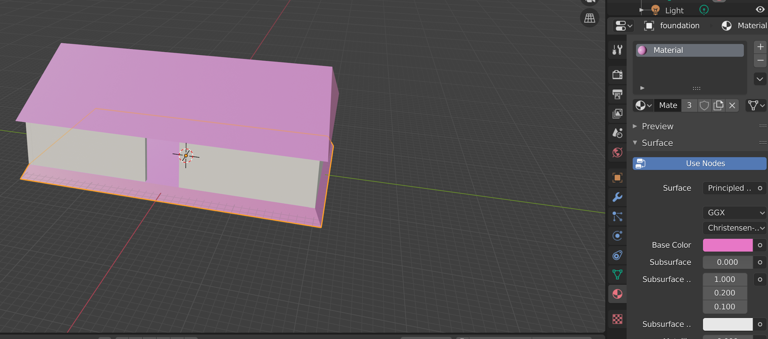

If you see the **3** in the image above, that is the number of linked objects to this material (your number may vary). Click it to make it a 'single texture.'

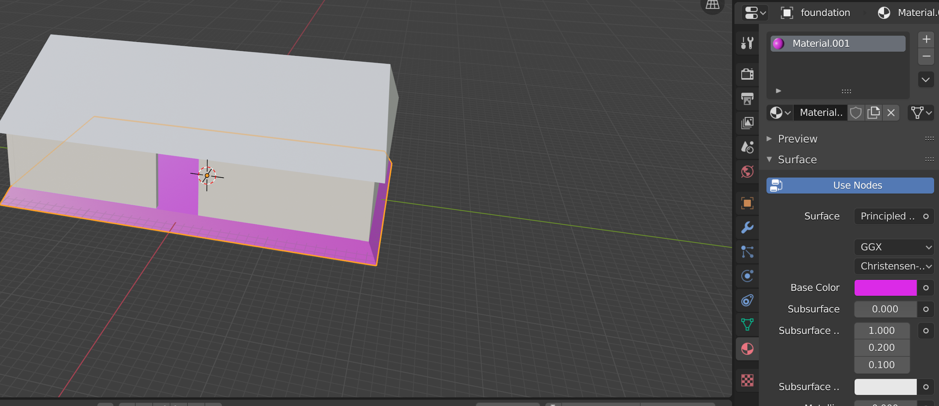

Now let's change it to stone. Click the little circle next to Base Color and select Image Texture. Select your downloaded stone texture.

Play around with the sizing of your UV map in the UV Editing workspace (select the vertices on the left and hit **s** to scale it).

In the Shading area, you can add some 'texture' to your texture. Add a Displacement node and hook it up like this:

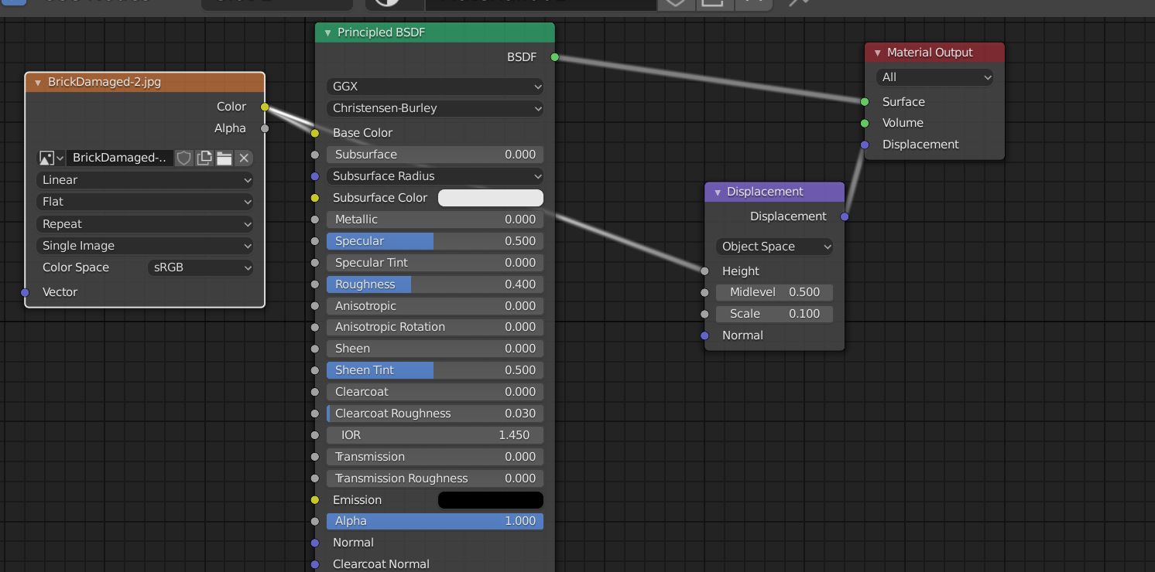

Play around with the scale value to give your floor some roughness/smoothness. Now apply wood to the walls, pick an appropriate texture for the roof, etc. Note that if your image comes in rotated incorrectly, you can rotate your UV map to adjust it properly (select map and hit 'R' to rotate).

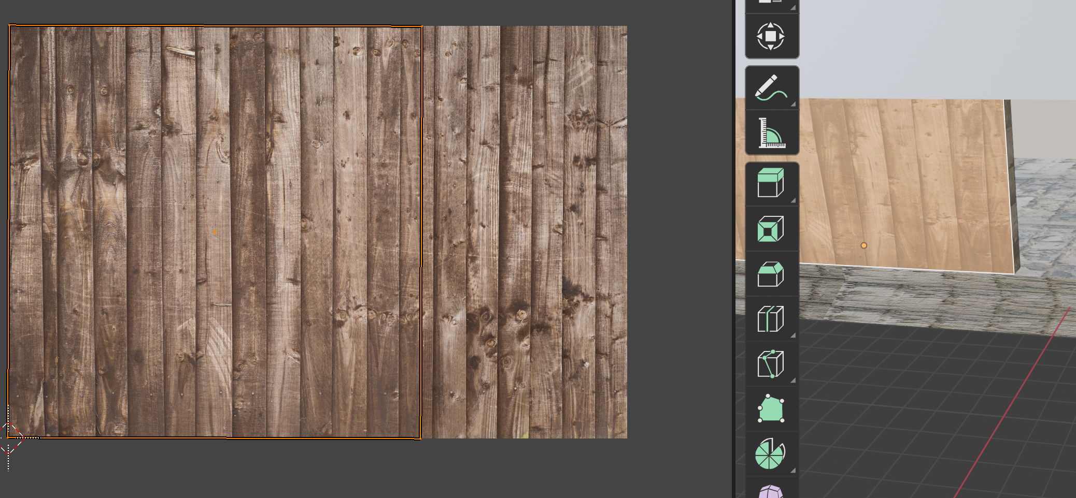

Regardless, **take a screenshot of your textured house with windows and paste it into Q1**.

**You don't have to do the parts with Unity. We'll save Unity for later.**

(These are reasonable video explanations for texturing if you need additional resources: <https://www.youtube.com/watch?v=mq4HMlefgDw> // <https://www.youtube.com/watch?v=GTd8NBg8EZU>)

Last but not least, let's export it for use in other projects. We'll use the Babylon sandbox (<https://sandbox.babylonjs.com/>).

Go to File → Export → glb / glTF 2.0. Pick your location and then expand the dropdowns on the right. In addition to what's already selected, you'll want to include Custom Properties, Cameras, Punctual Lights, and Apply Modifiers. You can save it as either a gltf or glb file (the former is a packaged object, the latter is a binary file). Drag and drop your exported file into the website above. You should see it in your browser. **Take a screenshot and paste into Q1.**

**Lab Report / Homework:**

1. Paste all screenshots here (there should be 4)

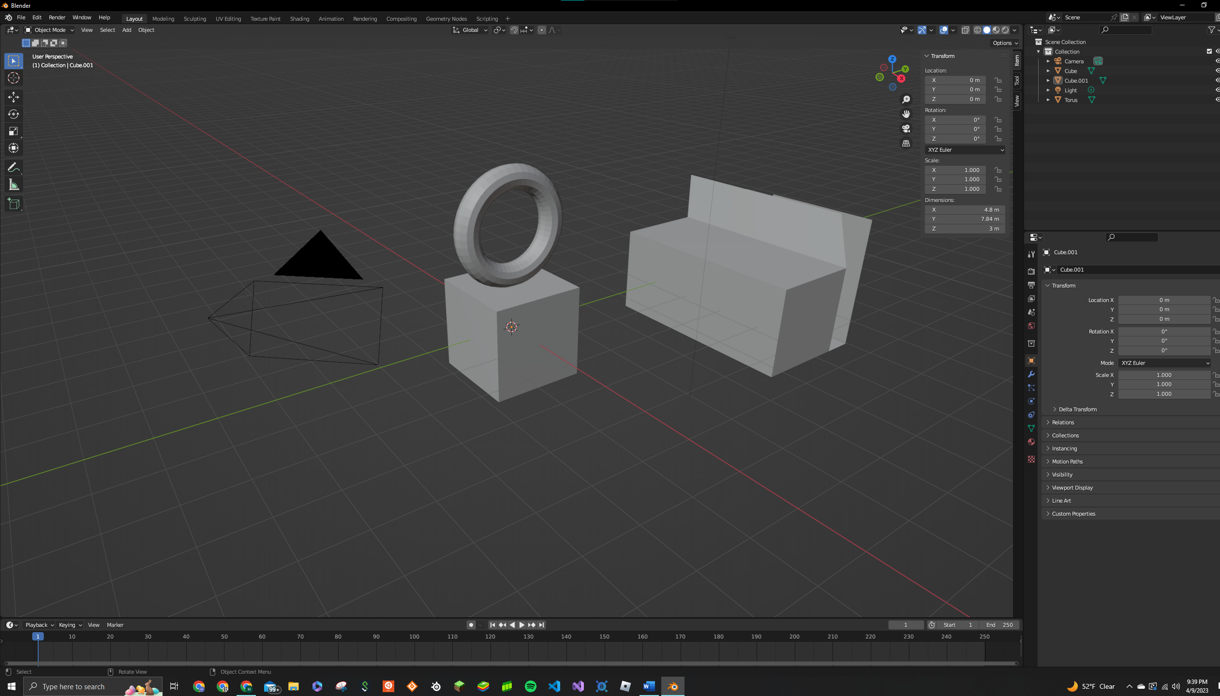

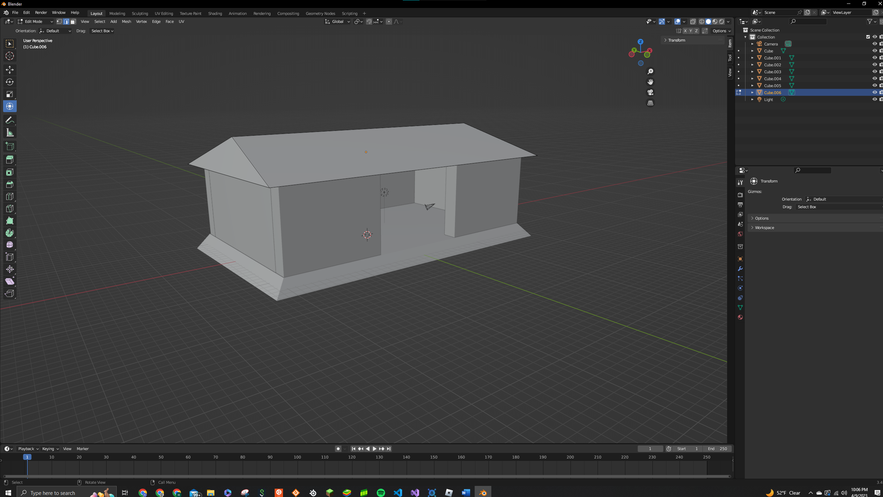

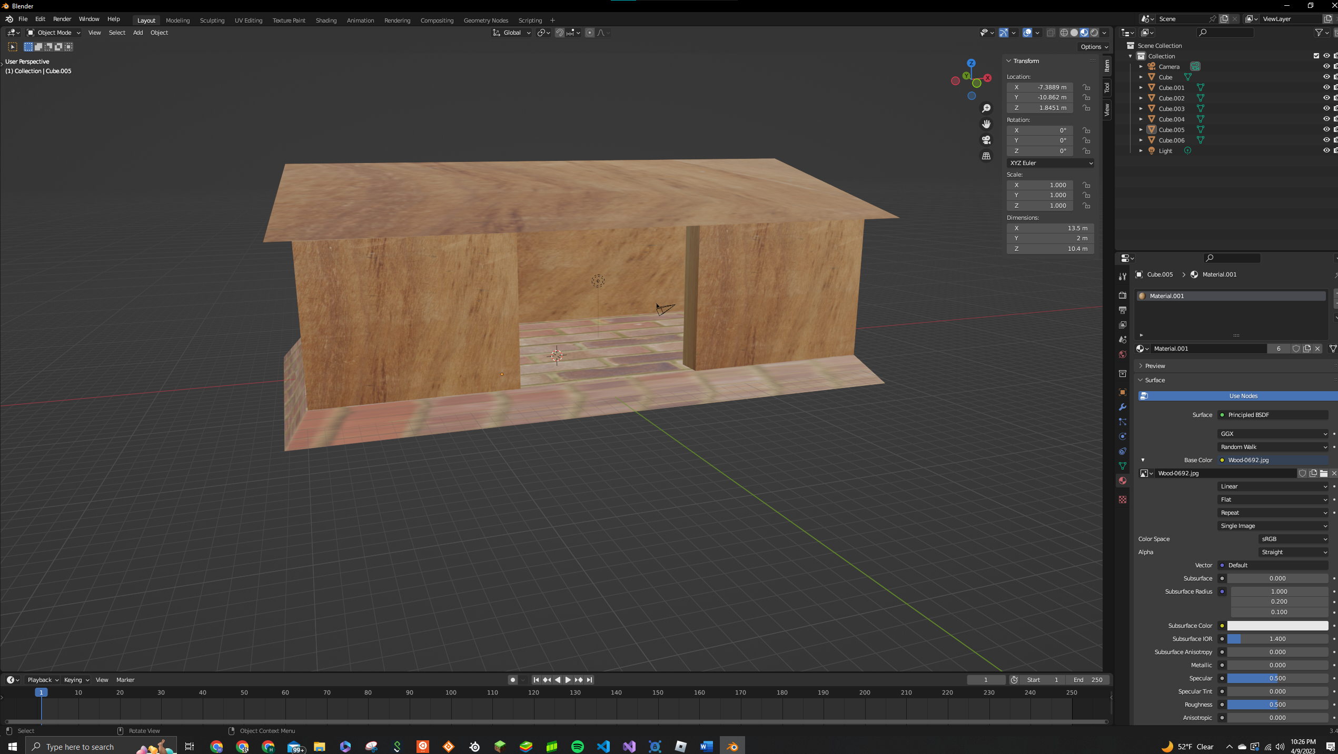

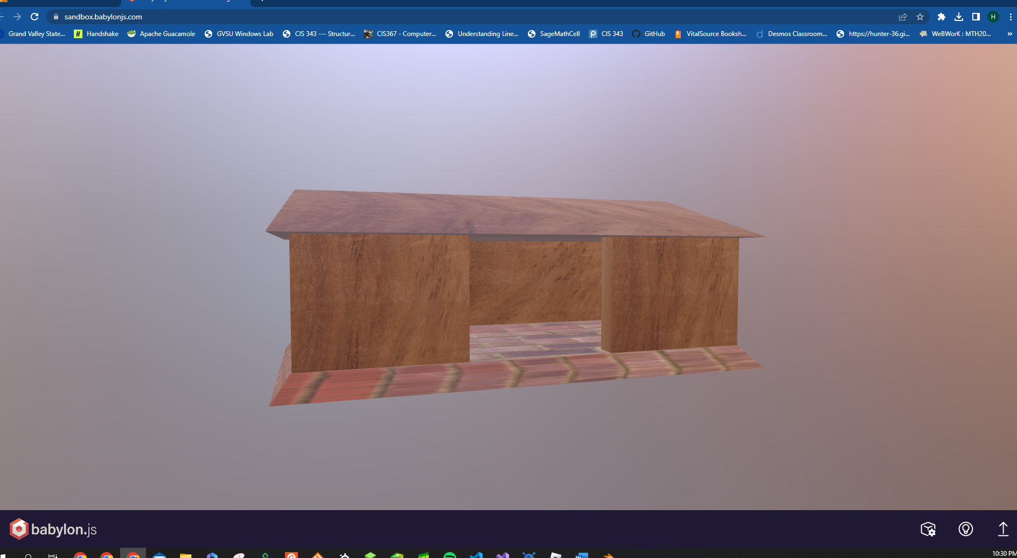

1. Where are you at with your term project?

I am at a point where I have a rigged and animated model and now I need to make a background scene for it to move in.

1. If you want to go for some extra credit, make your donut shrine a bit more 'realistic'
2. If you want some other extra credit, add on some impressive materials in the Shader editor, or do something interesting with Geometry nodes to the scene. Describe what you did here and show me screenshots of your node salad and output.